Sushma.H.M
Phone Number: +91 9901849879
Email ID: Sushma.hm84@gmail.com

Overall Work Experience: 4.6 years
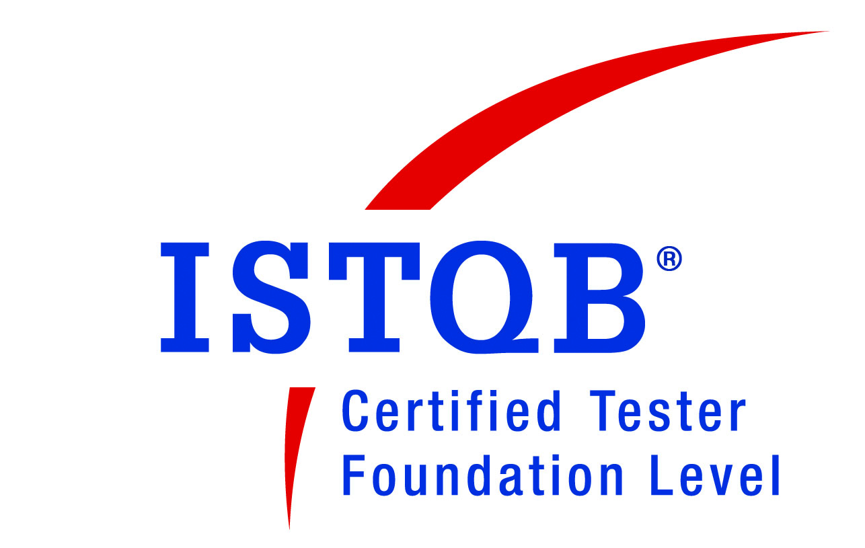

Professional experience
Tata Elxsi Ltd. Bang
(Worked for the client: SONY India Private Ltd.) :From April 2011 to till date
MAC Telecom Technologies :From August 2007 to Feb 2010

Competencies
Knowledge and experience in C, Linux, Automation testing, Manual testing and Agile methodology

Key Summary
Having 2.6 years of work experience in white box testing, Blackbox testing & automation
Having 3 years of Comprehensive experience in Telecom Billing, NMS, GIS Domain as a C Developer& tester
Hands-on experience in writing, reviewing and executing functional test scenarios
Very good experience in Automation & Manual Testing.
Preparing Test plans, Tracking Bugs, preparing Defect Status report and Test Summary report
Entitled the ISTQB certification in the year 2012
Runner up in Agile Excellence Quiz held in Tata Elxsi
Used python, selenium, Bobcat, C, XML scripting, python for test automation.
Good knowledge in Mysql, Linux /Windows OS for C development
Manual Testing, Documentation, Test Documents (Test Case, Test Scenario, Test Conditions and Test Report).

Skill Summary
Programming Languages :C, Python, Java 8, Shell Script
RDBMS: My SQL 5.0
OS : Windows Server 2003/2008 R2 Enterprise, Windows 7,Windows 8, LINUX
Tools : Selenium –Web Driver 2.5, Jmeter 2.7, BobCAT tool, Eclipse 4.3 Kepler, Bugzilla,Redmine Web application, Git, svn, Mysql Query Browser
Well Versed in Agile Methodology
Protocols Used: TCP/IP, UDP, FTP for Development

Content Relation Model
Testing type : Manual Testing, Black box testing,GUI testing, automation
Environnent : Python and Selenium
Solutions: PlayMemories Online (http://playmemoriesonline.com/)
Duration : 4 months (Dec 2013-till date)
Role: QAEngineer
Clients: SONYJapan
Responsibilities:
- Involved in client meetings and provided valuable suggestions in designing the Software Requirements
- Automated using python with selenium framework
- Developing test cases, reviewing and executing the same. Filing bugs and documenting those for future use.
- test plan preparation. Involved in Tracking Bugs, preparing Defect Status report and Test Summary report and in exit criteria of release
- Defect tracking and ensuring the status of the bugs after fixing. Preparing Defect Status report and Test Summary report
Additional Responsibilities:
Conductingknowledge sharing sessionsin the team
Involvement in client meetingson daily/weekly basis to convey the testing updates
Description:
CRM is an part of PMO(Play Memories Online). Which provides us usa account in the Cloud storage where we can store our memories like Photos, Videos, Even we can create albums and post cards and can be shared to Friends and family. CRM creates cluster IDS for the images with respect to the devices and frequency of shooting from which the image is uploaded to site. Each cluster id is associated with a banner. It also displays the corresponding banner for each user.

SociaLife
Testing type : Manual Testing, Black box testing, GUI testing, automation
Environnent : Python and Android 4.3, BobCATtool
Duration : 4 months (Aug 2013-Nov 2013)
Role : QA Engineer
Clients : SONY Japan
Responsibilities:
- Involved in client meetings and provided valuable suggestions in designing the Software Requirements
- Writing sociaLife scenarios, developing test cases, reviewing and executing the same. Filing bugs and documenting those for future use.
- test plan preparation. Involved in Tracking Bugs, preparing Defect Status report and Test Summary report and in exit criteria of release
- Tested and worked with the Bobcat framework to convert the manual test case execution into automation.
- Defect tracking and ensuring the status of the bugs after fixing. Preparing Defect Status report and Test Summary report
Additional Responsibilities:
Conductingknowledge sharing sessionsin the team
Involvement in client meetingson daily/weekly basis to convey the testing updates
Description:
Socialife News is an Android/Windows 8 App that enables you to check your Facebook posts, Tweets, YouTube videos, blog posts, and interesting news articles in one central place. It allows us to login from any facebook account and it also allows to post from multiple accounts. We can also add our interested RSS feeds/ news feeds from a particular sites. It provides almost the features of Facebook, twitter, VK and YouTube.
Play Memories Online [PMO]
Technologies:Automationusingselenium and BobCATtool
Environnent : Selenium 2.0, Python and Android 4.3, BobCATtool
Solutions : Play Memories Online (http://playmemoriesonline.com/)
Duration : 4 months (April 2013-July 2013 )
Role : QA Engineer
Clients : SONY Japan
Responsibilities:
- Automation test plan preparation.
- Writing automation scripts for the existing manual test cases, writing new sceanrios and automating the same
- Involved in Tracking Bugs, preparing Defect Status report and Test Summary report and in exit criteria of release
- Customising the BobCAT tool according to the test suites to ensure easy run.
- Demonstrating the work done to the clients periodically.
Additional Responsibilities:
Conductingknowledge sharing sessionsin the team
Involvement in client meetingson daily/weekly basis to convey the testing updates
Description:
Play Memories Online [PMO] provides us a account in the Cloud storagewherewecan store ourmemorieslike Photos, Videos, Evenwecancreate albums and post cards and canbeshared to Friends and family. Creating and sharing the Photobookis one more feature of this PMO. PMO appcanbedownloadedfrom the app store to the different SONY deviceslikePC, Mobile, TV, Camera, Tablet. PMO appwillenables the devices to upload photos/Videos to their PMO accountwhichcanbeaccessed and viewed in other SONY devices as well. PMO offersUnlimitedupload of Photos/Videoswhichcanbeeasilyorganised and shared.

Next Generation Portable(NGP)
Testing type : ManualTesting, Black box testing, GUI testing
Environnent : Windows
Duration : 14months(May2011- July 2012)
Role : QA Engineer
Clients : SONY Japan
Responsibilities:
- Requirements and Analysis: Understanding the requirements of the client and act as a sole functional resource
- Interacting with the client and clarify any queries regarding the functionality etc.
- Designing and implementation of Domain and scenario test cases.reviewing and executing the same. Filing bugs and documenting those for future use
- Automation of scenario and Domain testcases using XML and C
- GUI testing for a tool
- test plan preparation. Involved in Tracking Bugs, preparing Defect Status report and Test Summary report and in exit criteria of release
- Defect tracking and ensuring the status of the bugs after fixing. Preparing Defect Status report and Test Summary report
Description:
NGP (Next Generation Portable) is the Sony’s latest Play Station which released recently. NGP will use a new game medium, a small flash memory based card, dedicated for NGP software titles. The cards will store full game titles and add-on game content or save data. Sony notes that they'll be able to provide higher capacity cards in the future to allow developers to store more game data. The device also supports PlayStation Network Trophies. The NGP contains a touch screen on top and touchpad at the bottom. This allows player to interact with games through “touch, grab, trace, push and pull moves of fingers
Billing
Type : C development, Design, white box testing, GUI testing
Environnent : centOs
Protocolsused : TCP,UDP,FTP
Database : Mysql
Duration : 30 months(Mar 2007-Sep 2010)
Role : C Developer& tester
Organization : MAC Telecom Technologies
Clients : xenwei technologies
Responsibilities:
- Worked in Billing Project for Xenwei Technologies, Mongolia as a C Developer.
- Developed backend C application for Number server, Mediation server, CDR decoder for SMSC, conference and voice calls
- Developed code for billing of SMSC, Voice, conference calls.
- Used protocals like FTP, TCP,UDP for writing programs
- Bug fixing, and implementing new functionalities as a part of change requests.
- Testing: Done Unit Testing, Database Testing for SMSC, Conference and Voice module, white Box Testing, Integration Testing, Regression Testing for voice module and generate test result reports.
- Automation using basic shell script
- Written test cases for SMSC and Conference modules

Description:
Billing system provides complete solution for Voice, Data and Video billing requirements. It is a CDR (Call Detail Record) based Billing System. The Billing system will download that CDR file from various device resources like SOFTSWITCH, RADIUS and CDN through Mediation Server. Core CDR’s will be decoded and it will be rated through rate engine, as per the rate-plan package and services allotted to that customer. The invoice will be generated lively and the Invoice will be printed or e-mailed to customer.

Network Management System (NMS)
Testing type : GUI testing
Environnent: Linux
Duration : 3 months(Dec 2007-Feb 2007)
Role : tester
Organization : MAC Telecom Technologies
Clients : xenwei technologies
Responsibilities:
- Manual Testing for fault, configuration, Performance management.
- Developed backend code in C for soft switch configuration monitor
Description:
Network Management System (NMS) is a centralized software module which governs all the EMS’s (Element Management system) and NE’s (Network Elements) functioning under it. EMS interacts directly with NE’s of various vendors to exchange management information using SNMP protocol primitives and it will stores all management information of NE’s. This model consists of five conceptual areas that are called FCAPS functionalities.

Geographic interface System (GIS)
Type : C
Environnent : Linux,Windows
Duration : 4 months(Aug 2007-Nov2007)
Role : Developer
Organization : MAC Telecom Technologies
Clients: Tata Power
Responsibilities:
- Map visualizing and rendering
- Handling Raster and Vector data.
- Exporting External plugins
Description:
A Geographical system is a collection of software that allows you to create, visualize, query and analyze geospatial data. This often involves the use of geographic coordinate, like latitude or longitude value. Spatial data is another commonly used term, as are: geographic data, GIS data, map data, location data, coordinate data and spatial geometry data. Applications using geospatial data perform a variety of functions such as map production, map rendering, distance between geographic location, the amount of area etc.

EducationalQualification
B.E(Computer Science) from VTU, Belgaum in 2007
Diploma(Computer Science) from DTE, Bangalore in 2002

PersonalInformation
Name: Sushma H M
Husband Name:Raju P
Date of Birth:29th May 1984
Children : Baby boy
Marital Status:Married
Pan no# : CMUPS7639T

[Sushma H M]

